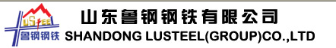
Add:Taishan district，tai'an city，Shandong province
Tel: 0086-538-6995786 Fax: 0086-538-6996328
―――――――――――――――――――――――――――――――――――――――

Dear sir，

Below is our popular and standard manufactured products for export,pls check.

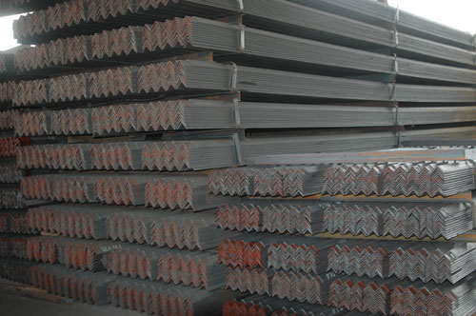

Hope to be your reliable supplier for long terms business

Best wishes /Amy

Shandong Lu steel Group
Add:Taishan district，tai'an city，Shandong province
Tel: 0086-538-6995786
Fax: 0086-538-6996328

